May 30 – July 30. 2022

Imagine Learning and Literacy

Summer Challenge

This unique summertime challenge is designed to prepare English Learner students for the upcoming school year and help them continue learning English.

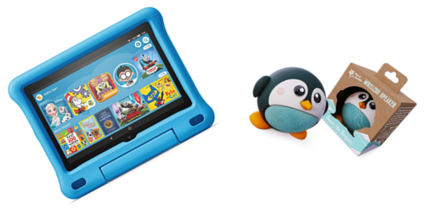

English Learner students using Imagine Language and Literacy for 350+ minutes from May 30 to July 30 will be automatically entered into a drawing for the Imagine Learning Summer Challenge Prizes by the ESOL Department.

The top five contenders will win a Fire Tablet, and the next top five contenders will win a wireless speaker.

The winners will be announced on Friday, August 19, 2022.

